**Forms to complete for the**

**Finance Professional Show**

**9th November 2016**

Within this section you will find all the forms you need to complete for the Finance Professional Show.

Please type directly in to these forms and return as a word document to [exhibitors@thefpshow.co.uk](mailto:exhibitors@thefpshow.co.uk)

**Furniture**

If you have a shell scheme stand at the event you will have a furniture allocation as part of your stand package. You have a choice of four options, simply indicate your preferred package choice in the form.

**Additional Items**

In addition to your stand at the event the Finance Professional Show offer a number of additional items to help you enhance your presence at the event.

These items include advertisements in the show programme, inserts in the delegate bags and badge scanners. If you would like to include any of these extras in your package please complete the enclosed form, confirmation of the additional orders will be sent to you.

**Names**

Please complete the enclosed form with the names of your team who will be on your stand for the event. We will prepare your badges in advance and they will be on your stand for the morning of the event. The access passes will give your team entry to the venue to collect badges.

**Risk Assessment & Health and Safety Declaration**

In line with the events industry Olympia have adopted a new approach to health and safety at events, known as Construction, Design and Management (CDM). This includes enhanced requirements that all exhibitors must comply with during the build and breakdown elements of the event.

As detailed within the Key Exhibitor Information **all** members of your team that are on site for either build or breakdown must be wearing Hi-Vis clothing and appropriate footwear. We strongly recommend that you bring your own to prevent queuing, you will not be permitted access to the load bay without Hi-Vis clothing, this can be a vest or jacket. These can be purchased here <https://www.hivis.co.uk/hi-visibility/hi-vis-vests/hi-vis-vests-waistcoats-sleeveless.html>

All exhibitors are required to complete a risk assessment form to demonstrate they have considered any hazards or risks that may occur on your stand while you are exhibiting at the event, this can include slips, trips, falls, manual handling or equipment malfunction.

A Health and Safety Declaration must be completed by each exhibiting company.

If you are using a stand contractor to assemble your stand, they will also need to complete these forms. Please ensure you have provided us with their details on your declaration.

|  |  |
| --- | --- |
| **Deadlines** | |
| Furniture | 16th October |
| Additional Items | 16th October |
| Name Badge Request Form | 16th October |
| Contractor Risk Assessments | 28th September |
| Exhibitor Risk Assessment | 16th October |
| Health and Safety Declarations | 16th October |



Furniture Packages

**Package A** **Package B**

2 Folding Chairs (CR02) 2 Taylor Chairs (CR03)

1 Trestle Table (TE11) 1 Disk Bistro Table (TE01)

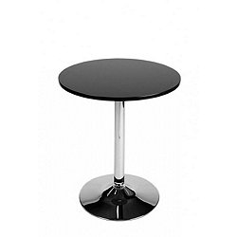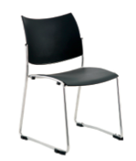



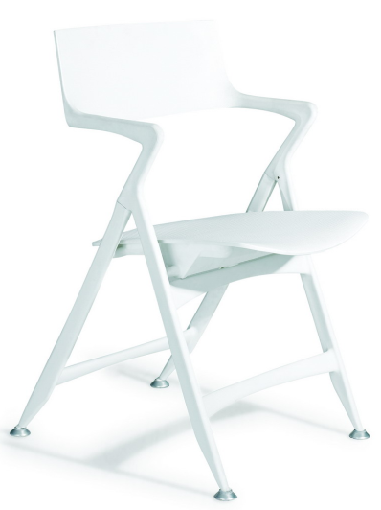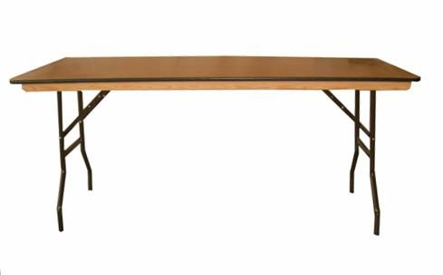

**PACKAGE C PACKAGE D**

2 Bow Stools (SL03) 2 Marco Chairs (LE03)

1 Poseur Table (TE16) 1 Disk Coffee Table (CE01)

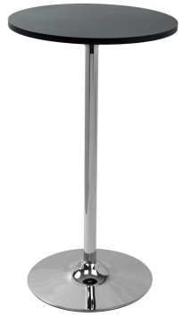

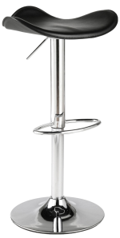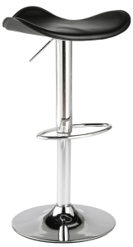



Extras



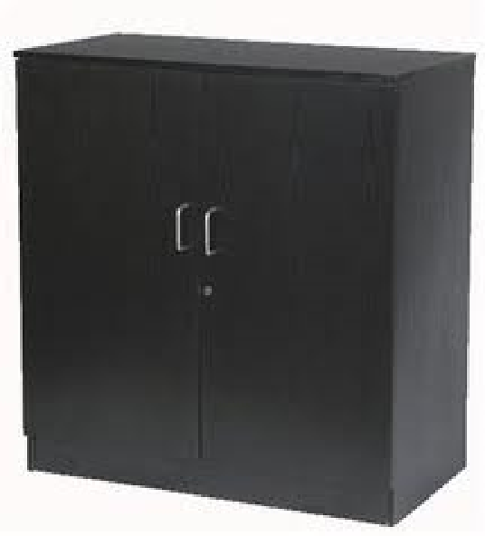



**Add a Cupboard or Literature Rack £50 Add a showcase for £125**



For our full furniture brochure please visit [www.3rdelement.co.uk](http://www.3rdelement.co.uk)

Contact Office 02476 457474

3rd Element Ltd – Email us at [info@3rdelement.co.uk](mailto:info@3rdelement.co.uk) with any enquiries



If you have ordered a bronze, silver or gold package you may order one of the furniture options A, B, C or D with no additional charge.

|  |  |  |
| --- | --- | --- |
| **Company Name** | **Your Name** | **Package** |
|  |  |  |

Should you wish to order additional items please list them below, all additional orders will be confirmed to you with an email and invoice before the event.

|  |
| --- |
| **Additional Furniture Items** |
| **1.** |
| **2.** |
| **3.** |
| **4.** |

For our full furniture brochure please visit [www.3rdelement.co.uk](http://www.3rdelement.co.uk)

Contact Office 02476 457474

3rd Element Ltd – Email [info@3rdelement.co.uk](mailto:info@3rdelement.co.uk) with any enquiries



**Opportunities available at the event**

**In addition to your stand at the event The Finance Professional Show offers a number of additional ways you can enhance your presence at the event and assist with your data collection saving you time and money.**

**Advertisement in the Show Programme**

The Show Programme is given out to all visitors and exhibitors at The Finance Professional Show. You can increase your presence at the event by placing a full or half page full colour advertisement within the show programme. The programme is often used as a reference tool by delegates after the event.

**What happens next?**

To book your advertisement complete and return the booking form. You will be sent the advertising specifications along with the deadline for the advert. This will appear in the show programme at the event.

**Badge Scanner Hire**

Each delegate who visits your stand will have a name badge with a unique bar code.

By scanning the badge you will be able to capture the contact details of the delegate including; name, company name, contact number and contact email address, saving you time collating data and giving you more opportunity to have meaningful discussions on site.

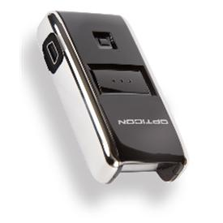

All scanners will be available to hire at £150 plus VAT per unit and must be paid for in full before the event.

**What happens next?**

At the exhibition, please make your way to the organiser’s office at the start of the show to sign out your scanner, a full demonstration of the scanner will be offered. At the end of the event simply sign your scanner back in to the event team and your spreadsheet of data will be provided to you within four business days of the event.

**Bag Insert**

You can further enhance your exposure at The Finance Professional Show by placing an insert in the delegate bag, given out to all visitors and exhibitors at the event. This insert can be a brochure, a leaflet or a branded item.

**What happens next?**

To book your insert complete the attached booking form and return. Your insert will need to be delivered to the venue for 1pm on the morning of 7th November. We will be in touch with you to confirm we have received your booking and will confirm the arrangements for your delivery.



**ADDITIONAL ORDERS BOOKING FORM**

**SELECT YOUR ITEMS, COMPLETE THE FORM AND RETURN**

**WE WILL CONFIRM YOUR BOOKING UPON RECEIPT OF YOUR FORM**

|  |
| --- |
| **Name of Exhibition:** **The Finance Professional Show**  **Dates of Exhibition:** **9th November 2016**  **Venue of Exhibition:** **Olympia Central, London** |

|  |  |  |  |  |
| --- | --- | --- | --- | --- |
| Item | Cost | Vat | Total Cost | Select |
| Half Page Advert | £250.00 | £50.00 | £300.00 |  |
| Full Page Advert | £500.00 | £100.00 | £600.00 |  |
| Bag Insert | £250.00 | £50.00 | £300.00 |  |
| Scanner | £150.00 | £30.00 | £180.00 |  |
| 2nd Scanner | £150.00 | £30.00 | £180.00 |  |

|  |  |
| --- | --- |
| **TOTAL AMOUNT FOR ITEMS SELECTED** | **Cost: £ Plus VAT:** **£**  **Total Cost: £** |

|  |  |  |  |
| --- | --- | --- | --- |
| **COMPANY DETAILS (please ensure all boxes are complete)** | | **INVOICING DETAILS (please ensure all boxes are complete)** | |
| CONTACT NAME: | | INVOICE CONTACT NAME: | |
| **POSITION IN COMPANY:** | | PURCHASE ORDER NO: | |
| COMPANY NAME: | | INVOICE COMPANY: | |
| ADDRESS: | | INVOICE ADDRESS: | |
| CONTACT PHONE NUMBER: | | INVOICE PHONE NO: | |
| CONTACT EMAIL: | | INVOICE EMAIL: | |
| **I acknowledge and accept that this booking is made subject to the exhibition terms and conditions which I have read and that I am authorised to sign this confirmation on behalf of my company.** | |

**FORM COMPLETED BY on behalf of**

**NAME (CAPITALS) TITLE DATE**

|  |
| --- |
| **Your information may be passed to third party companies associated with the event unless we are notified to the contrary in writing or by email to info@rr-events.co.uk** |

**The Finance Professional Show Stand Staff List**

All of the personnel on your stand will need to wear individual name badges during the show.

Please complete the below grid by typing in to the appropriate column ensuring you include all members of staff who will be on your stand.

You may insert rows for additional personnel if required.

Your name badges will be on your stand ready for show open day.

|  |  |
| --- | --- |
| *Company name as you wish it to appear on the stand nameboard(s)* | |
| *Stand number* | |
| *Name as you wish it to appear on the badge* | *Company Name* | *Email Address* |
|  |  |  |
|  |  |  |
|  |  |  |
|  |  |  |
|  |  |  |
|  |  |  |
|  |  |  |
|  |  |  |
|  |  |  |
|  |  |  |
|  |  |  |
|  |  |  |
|  |  |  |
|  |  |  |

**Health and Safety Declaration**

Olympia, in line with the events industry, has introduced new health and safety measures for all exhibitions. This is known as Construction, Design and Management Regulations (CDM) and looks at each exhibition build area as a construction zone. With that in mind all personnel on site during show build and breakdown must wear hi-vis clothing and sensible footwear. Each stand will need to have a nominated member of the team who is your health and safety representative.

Finance Professional Show 2016

Company Name:

Stand Number:

Our nominated principal Health and Safety Representative for the Stand is:

Name:

Position:

Contact Number:

**This is the person responsible for your activities on site and on the stand, not those of your contractor**

As principal Health and Safety representative for your stand, you may need to produce a copy of your Health and Safety Policy upon request by the appropriate authorities whilst on site at the Exhibition.

It is your responsibility to

* be in possession of your Company’s Health and Safety Policy
* ensure all team members who are on site during build-up and breakdown of the event are wearing hi-visibility waistcoats and sensible footwear
* ensure there is adequate welfare provision for your team members on site
* ensure you have completed a risk assessment for your activities relating to the show
* have checked that your main stand fitting contractor has a suitable and sufficient Health and

Safety Policy for the event (if using a contractor)

* have checked that your principal Stand contractor has provided sufficient training for

his/her employees to carry out their tasks safely and competently for the event (if using a contractor)

If you are using a stand contractor to build your stand please complete their details below

Company:

Contact Name:

Position:

Contact Number:

Email Address:

**Please note: They will also need to complete this form. We will contact them to follow up.**

We have read and understood our responsibilities as laid out in the Health and Safety at Work Act 1974, and taken note of the most common areas of risk. We accept our responsibilities as laid out in this Act and all relevant legislation covering Olympia, including the Construction Design and Management Regulations 2007 and the Disability Discrimination Act.

**Form completed by:**

**NAME TITLE DATE**

**Further information regarding CDM can be found here** [**http://www.cdm4events.org.uk/exhibitors**](http://www.cdm4events.org.uk/exhibitors)

|  |  |  |  |  |  |  |  |  |  |  |  |  |
| --- | --- | --- | --- | --- | --- | --- | --- | --- | --- | --- | --- | --- |
| **Exhibitor Risk Assessment** | | | | | | | | | | | | |
|  | | | | | | | | | | | | |
| This risk assessment is designed to highlight the risks, those at risk and the control measures needed in an exhibition situation. This covers the setting up, staffing and breaking down of your stand. | | | | | | | | | | | | |
| **Instructions for use:** | | | | | | | | | | | | |
| 1. Cross reference the risk in column 1 with those at risk in column 2 and place a cross in the corresponding box. If the risk is not applicable leave the boxes blank. | | | | | | | | | | | | |
| 2. In column 3 please detail the control measures you will have in place to overcome these risks e.g. cable ramps, trained staff etc… | | | | | | | | | | | | |
| 3. Type the details of the person completing this form at the bottom | | | | | | | | | | | | |
|  | | | | | | | | | | | | |
| **Example:** | | | | | | | | | | | | |
| Column 1 - Risks | Column 2 – Those at risk | | | | | | | | | | | Column 3 – Control measure you have put in place |
|  | Own staff | Agency Staff | Venue Staff | Organisers | Other Exhibitors | Visitors/public | Pregnant workers | Contractors | Disabled persons | Lone workers | All persons on site | **Control measures to be taken: to include but not limited to; adequate guarding, PAT, sufficient lighting, cable ramps.** |
| * Electric Shock | X |  |  |  |  | X |  |  |  |  |  | All equipment on stand is tested, power supply installed by nominated contractors |
| * Ignition sources |  |  |  |  |  |  |  |  |  |  |  | Stand will be kept clear of litter, electrical equipment does not overload power ordered |
| * Slip, trip or fall |  |  |  |  |  |  |  |  |  |  | X | stand furniture kept within stand boundaries, excess boxes put into storage |
| * Long hours | X |  |  |  |  |  | X |  | X | X |  | Staff rota in place & breaks provided |
| Please complete below for the Expo you are attending: | | | | | | | | | | | | |
| Column 1 - Risks | Column 2 – Those at risk | | | | | | | | | | | Column 3 – Control measure you have put in place |
|  | Own staff | Agency Staff | Venue Staff | Organisers | Other Exhibitors | Visitors/public | Pregnant workers | Contractors | Disabled persons | Lone workers | All persons on site | **Control measures to be taken: to include but not limited to; adequate guarding, PAT, sufficient lighting, cable ramps.** |
| **People Issues** | | | | | | | | | | | | |
| * Manual Handling |  |  |  |  |  |  |  |  |  |  |  |  |
| * Lone workers |  |  |  |  |  |  |  |  |  |  |  |  |
| * Inexperienced / untrained Staff |  |  |  |  |  |  |  |  |  |  |  |  |
| * Verbal abuse |  |  |  |  |  |  |  |  |  |  |  |  |
| * Physical attacks |  |  |  |  |  |  |  |  |  |  |  |  |
| * Long hours |  |  |  |  |  |  |  |  |  |  |  |  |
| * Communication issues |  |  |  |  |  |  |  |  |  |  |  |  |
| * Alcohol & drugs |  |  |  |  |  |  |  |  |  |  |  |  |

Continued overleaf

|  |  |  |  |  |  |  |  |  |  |  |  |  |  |  |  |  |  |  |  |  |  |  |  |  |  |
| --- | --- | --- | --- | --- | --- | --- | --- | --- | --- | --- | --- | --- | --- | --- | --- | --- | --- | --- | --- | --- | --- | --- | --- | --- | --- |
| Column 1 - Risks | Column 2 – Those at risk | | | | | | | | | | | | | | | | | | | | | | | | Column 3 – Control measure you have put in place |
|  | Own staff | | Agency Staff | | Venue Staff | | Organisers | | Other Exhibitors | | Visitors/public | | Pregnant workers | | Contractors | | | Disabled persons | | Lone workers | | All persons on site | | |  |
| **Equipment** | | | | | | | | | | | | | | | | | | | | | | | | | |
| * Electric shock | |  | |  | |  | |  | |  | |  | |  | |  | | |  | |  | |  |  | |
| * Cutting | |  | |  | |  | |  | |  | |  | |  | |  | | |  | |  | |  |  | |
| * Trapping | |  | |  | |  | |  | |  | |  | |  | |  | | |  | |  | |  |  | |
| * Puncturing | |  | |  | |  | |  | |  | |  | |  | |  | | |  | |  | |  |  | |
| * Crushing | |  | |  | |  | |  | |  | |  | |  | |  | | |  | |  | |  |  | |
| * Portable tools | |  | |  | |  | |  | |  | |  | |  | |  | | |  | |  | |  |  | |
| * Trailing cables | |  | |  | |  | |  | |  | |  | |  | |  | | |  | |  | |  |  | |
| * Mobile Equipment | |  | |  | |  | |  | |  | |  | |  | |  | | |  | |  | |  |  | |
| * Impact injuries | |  | |  | |  | |  | |  | |  | |  | |  | | |  | |  | |  |  | |
| * Power Overload | |  | |  | |  | |  | |  | |  | |  | |  | | |  | |  | |  |  | |
| * Transportation | |  | |  | |  | |  | |  | |  | |  | |  | | |  | |  | |  |  | |
| * Set Up of equipment | |  | |  | |  | |  | |  | |  | |  | |  | | |  | |  | |  |  | |
| * Breakdown of equipment | |  | |  | |  | |  | |  | |  | |  | |  | | |  | |  | |  |  | |
| * Moving parts | |  | |  | |  | |  | |  | |  | |  | |  | | |  | |  | |  |  | |
| **Materials/substances** | | | | | | | | | | | | | | | | | | | | | | | | | |
| * Substance ingestion | |  | |  | |  | |  | |  | |  | |  | |  | | |  | |  | |  |  | |
| * Substance injection | |  | |  | |  | |  | |  | |  | |  | |  | | |  | |  | |  |  | |
| * Substance Absorption | |  | |  | |  | |  | |  | |  | |  | |  | | |  | |  | |  |  | |
| * Substance inhalation | |  | |  | |  | |  | |  | |  | |  | |  | | |  | |  | |  |  | |
| * Oil & grease | |  | |  | |  | |  | |  | |  | |  | |  | | |  | |  | |  |  | |
| * Irritants | |  | |  | |  | |  | |  | |  | |  | |  | | |  | |  | |  |  | |
| **Environment** | | | | | | | | | | | | | | | | | | | | | | | | | |
| * Poor floor surfaces | |  | |  | |  | |  | |  | |  | |  | |  | | |  | |  | |  |  | |
| * Poor lighting | |  | |  | |  | |  | |  | |  | |  | |  | | |  | |  | |  |  | |
| * Access & egress | |  | |  | |  | |  | |  | |  | |  | |  | | |  | |  | |  |  | |
| * Slips, trips or falls | |  | |  | |  | |  | |  | |  | |  | |  | | |  | |  | |  |  | |
| * Falling objects | |  | |  | |  | |  | |  | |  | |  | |  | | |  | |  | |  |  | |
| * Vehicle movement | |  | |  | |  | |  | |  | |  | |  | |  | | |  | |  | |  |  | |
| * Fire | |  | |  | |  | |  | |  | |  | |  | |  | | |  | |  | |  |  | |
| * Poor housekeeping | |  | |  | |  | |  | |  | |  | |  | |  | | |  | |  | |  |  | |
|  | | | | | | | | | | | | | | | | | | | | | | | | | |
| Form Completed by: | | | | | | | | | | | | | | | | | Stand Number: | | | | | | | | |
| Company Name: | | | | | | | | | | | | | | | | | Position in Company: | | | | | | | | |
|  | | | | | | | | | | | | | | | | | Date: | | | | | | | | |